**BLOCKCHAIN TECHNOLOGY**

* GO TO CHROME AND OPEN REMIX PLATFORM.

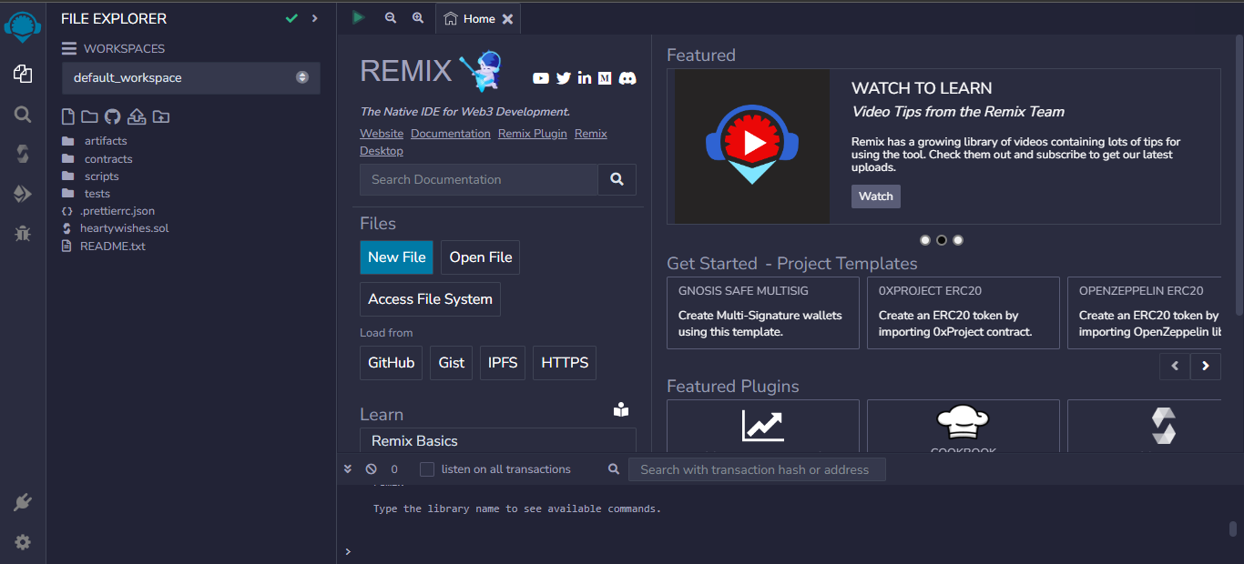

* THE REMIX PAGE AND CREATE A NEW FILE.

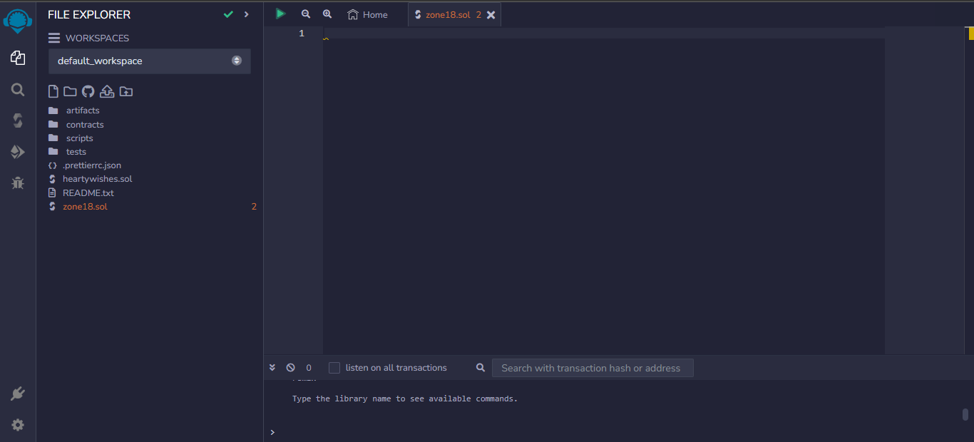

* IN THAT NEWLY CREATED FILE,CREATE A PROGRAM TO RETURN YOUR STRING,”ZONE NAME”.

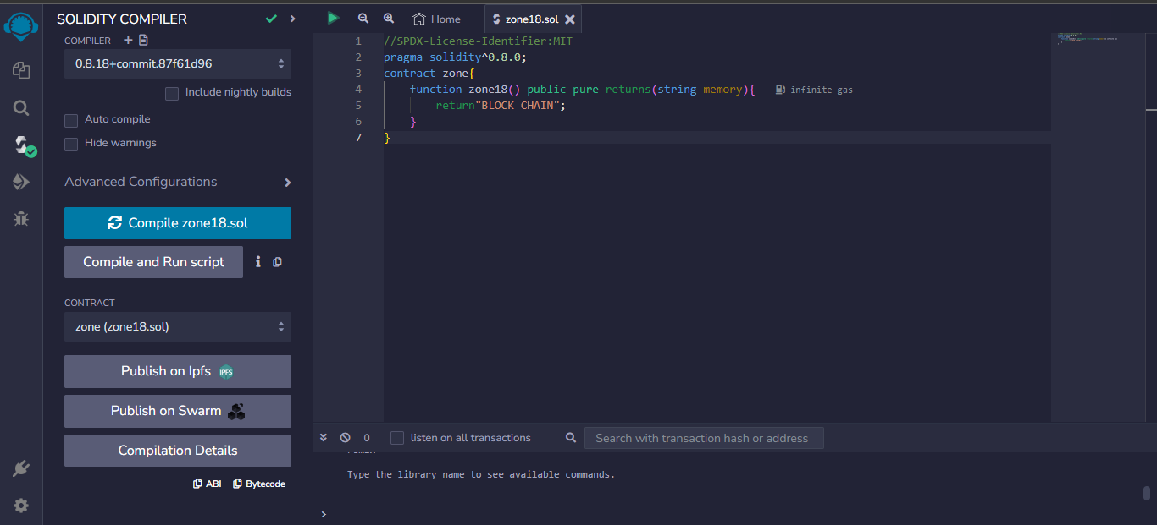

* SAVE THE PROGRAM AND COMPILE IT TO GET ABI AND BYTECODE.

ABICODE:

[

{

"inputs": [],

"name": "zone18",0

"outputs": [

{

"internalType": "string",

"name": "",

"type": "string"

}

],

"stateMutability": "pure",

"type": "function"

}

]

BYTECODE:



* FINALLY DEPLOY IT TO DISPLAY THE OUTPUT.

